Fall 2025 Horn Placement Auditions

Solo:
Excerpt from Arnold Fantasy for horn
Excerpts:
Jenkins- American Overture, mm. 80-104
Bernstein- Overture to Candide, 178-201
Respighi- Pines of Rome, mm. 9-25, 45-53, & 82-118
Williams- The Cowboys Overture, mm. 147-167

* Supplemental Material will be sent out 2 weeks before the audition for those wanting to be considered for wind ensemble placement.

Solo
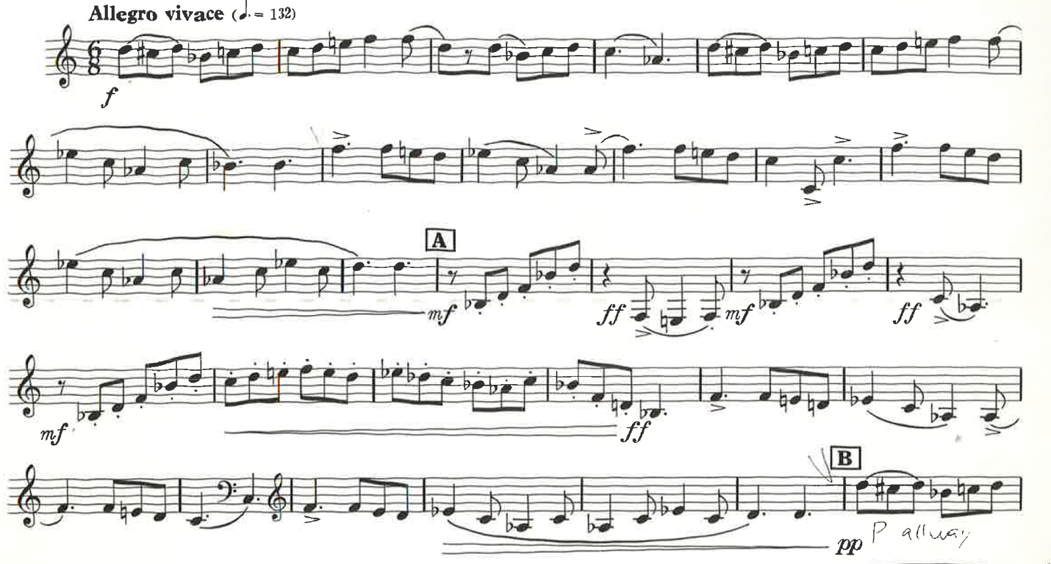

Excerpts
Jenkins (Gestoft = Stopped horn)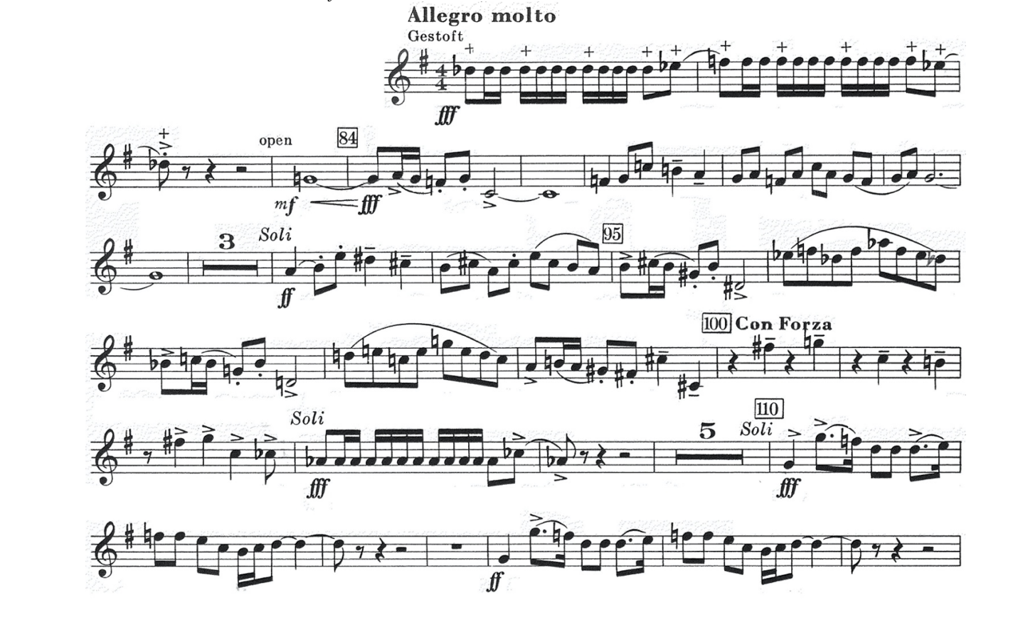Bernstein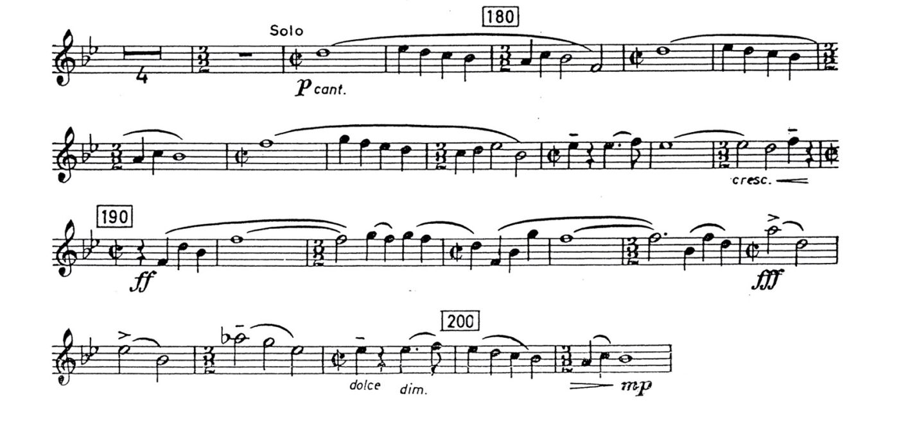
Respighi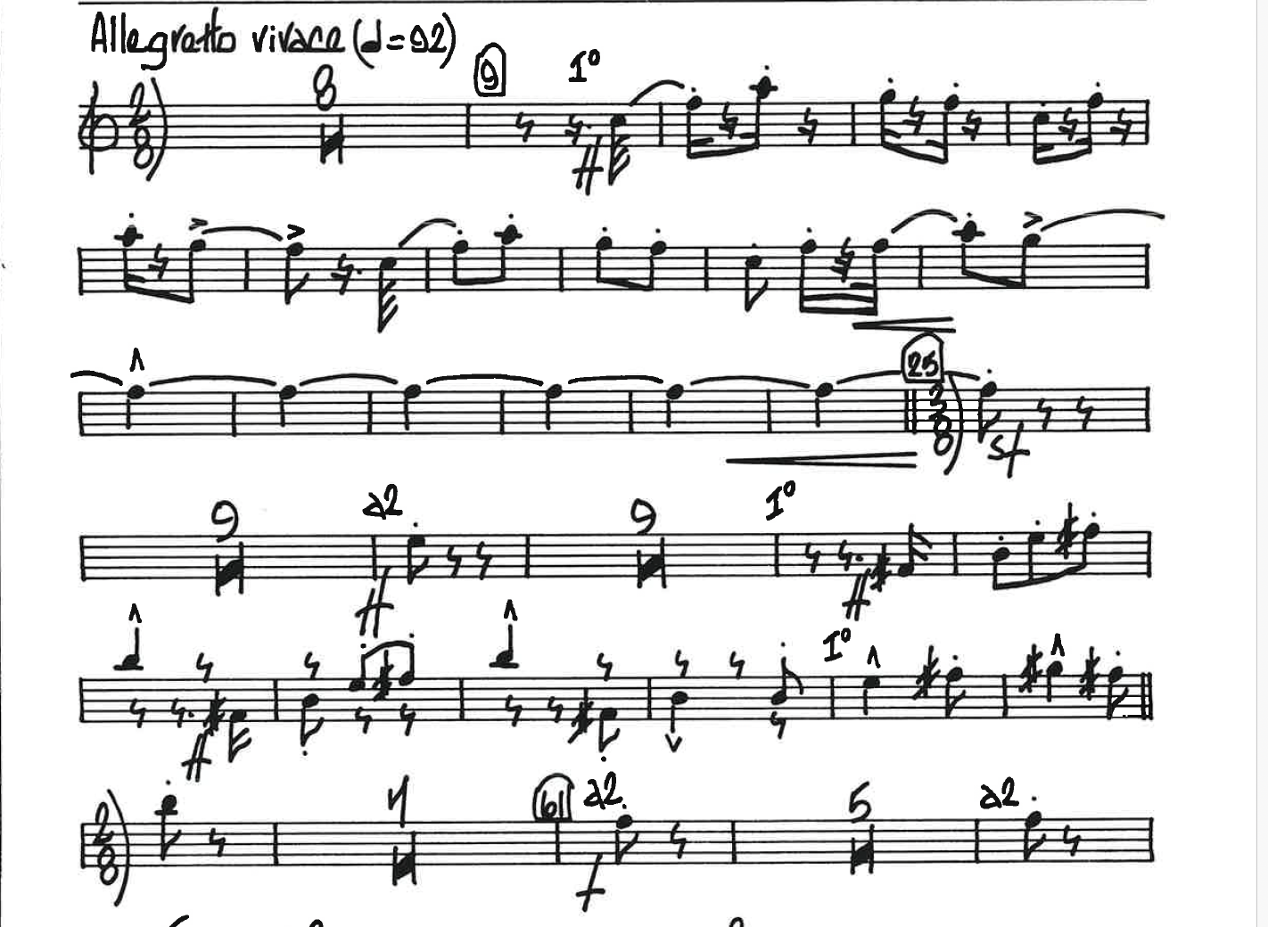 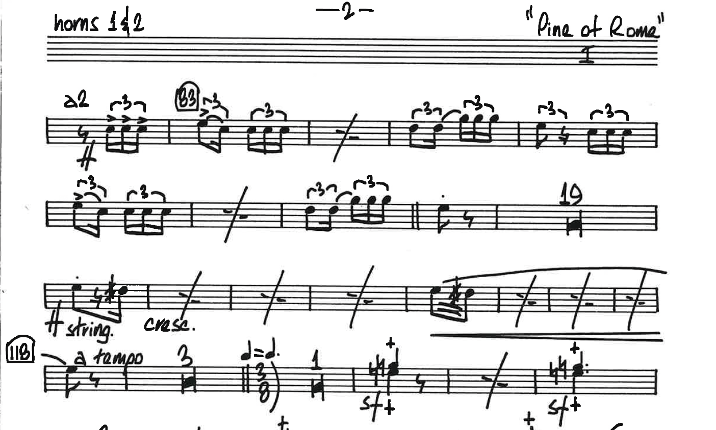 Williams 