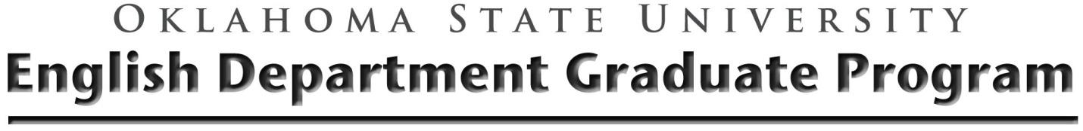
Demonstrating Language Proficiency Form
This form must be submitted to the Graduate Office.
Name:
Degree Program:
I am requesting Language Knowledge credit in the following language:
I have acquired proficiency as the result of (check at least one option):
☐ native proficiency in a language other than English
☐ a language translation test
☐ a three-credit hour upper division undergraduate course
☐ a three-credit hour graduate language course.
☐ written proof of satisfactorily completing a language requirement for a Master’s degree at another institution.
☐ a year of residence and study in an area where the language is spoken
☐ alternative method approved by the student’s advisory committee

The language requirement must be fulfilled prior to taking Qualifying Examinations or defending a Thesis/Dissertation. Discussion of how the language requirements will be achieved should occur during your Plan of Study meeting. When requesting advisory committee signatures, please share with your committee and the Graduate Studies Office any necessary documentation for demonstrating language proficiency (e.g., memos, certificates, or other documentation).
Advisory Committee Signatures
_______________________________________
_______________________________________
_______________________________________
_______________________________________

