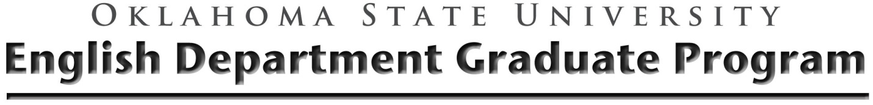

Demonstrating Language Proficiency Form : Native/Primary Language
This form must be submitted to the Graduate Office.
Name

Degree Program

I am requesting Mastery level credit in my native/primary language ________________________.

Advisory Committee Signatures

________________________________________________

________________________________________________

________________________________________________

________________________________________________

