Zoom User Logon Instructions

- In your browser, navigate to https://okstate-edu.zoom.us and select “Sign in”
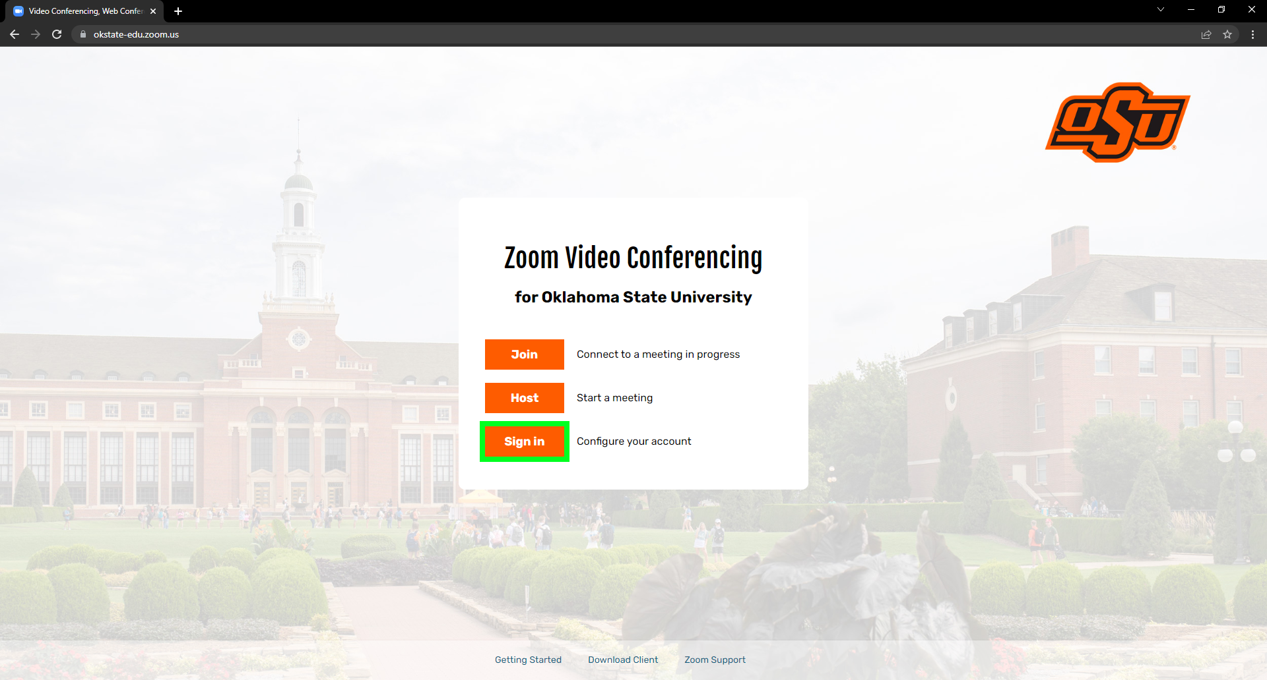
- Login using your O-Key email address and password.
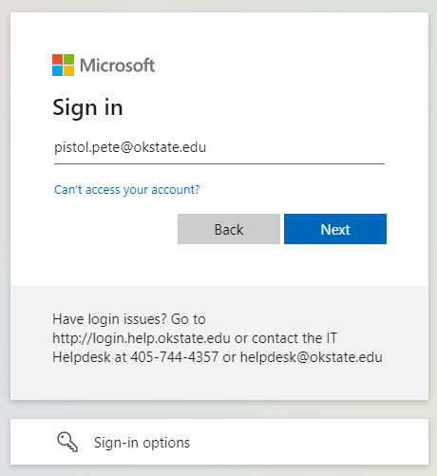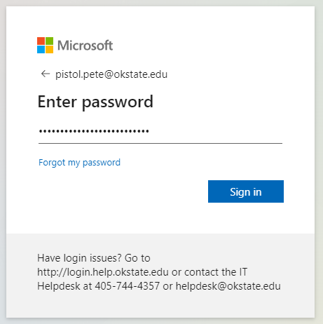

- If prompted by DUO, select your preferred Multifactor Authentication method.
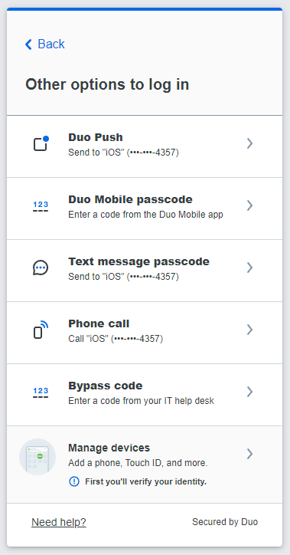
- You may be prompted to “Stay signed in?” select either Yes or No to continue.
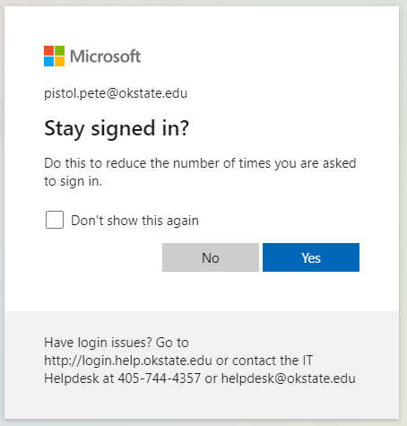
- You will be asked to give permission to Zoom, click the “Accept” button to continue.
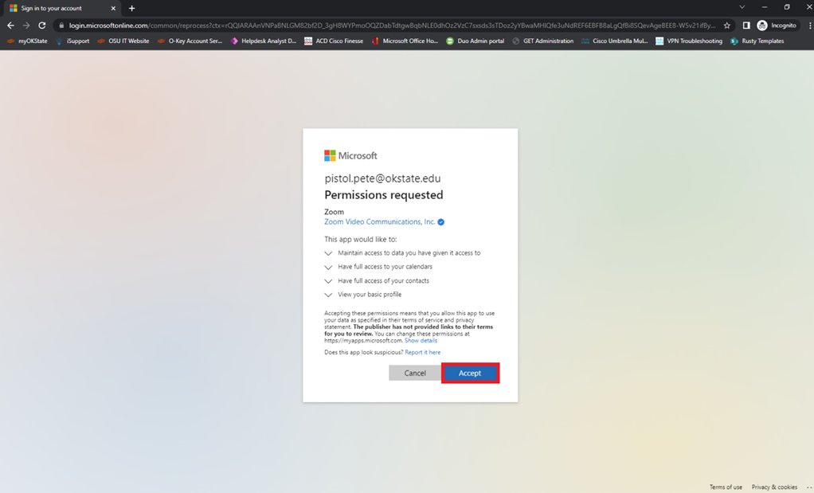
- After Clicking “Accept” you will be redirected to your Zoom Profile page.
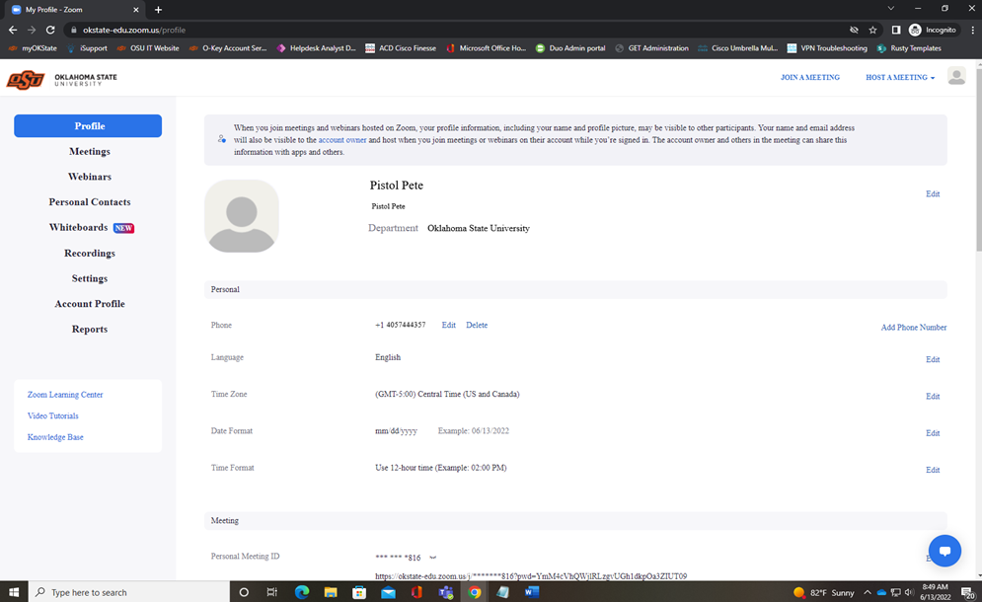
- Congratulations, you are registered with Oklahoma State Zoom Video Conferencing Solution!

